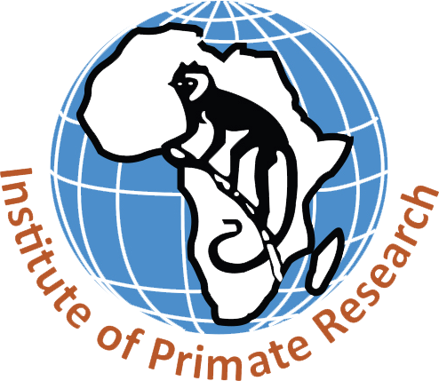

**Institute of Primate Research**

|  |  |  |  |  |
| --- | --- | --- | --- | --- |
| **SOP No.** | **Issue Number** | **Issue Date** | **Revision Status** | **Revision Date** |
| **SOP/KIPRE/RPD/DSAS/3.1.76** | **Version 01** | **October 2025** | **-** | **-** |

**STANDARD OPERATING PROCEDURE (SOP) DOCUMENT**

**Alignment of DS&AS processes with Institutional and National Regulations**

|  |  |  |  |
| --- | --- | --- | --- |
| **Approvals** |  |  |  |
|  | **Name** | **Signature** | **Date** |
| **Developed by:** | _Patrick Waweru Mwaura_ | **____________________** | **_6th October; 2025_** |
|  | ____________________ | **____________________** | **_______________** |
|  | ____________________ | **____________________** | **_______________** |
| **Reviewed by:** | **____________________** | **____________________** | **_______________** |
| **Approved by:** | **____________________** | **____________________** | **_______________** |

|  |  |  |  |
| --- | --- | --- | --- |
|  |  |  |  |

**Table of Contents**

1. PURPOSE 4

2. SCOPE 4

3. PERSONS RESPONSIBLE: 4

4. FREQUENCY 4

5. MATERIALS 4

6. PROCEDURE 5

7. REFERENCES 6

# 

# PURPOSE

To provide a standardized procedure for ensuring that all DS&AS processes, including data collection, storage, analysis, sharing, and reporting, comply with the Kenya Data Protection Act (2019), institutional data governance policies, ethical standards, and international best practices.

# SCOPE

This SOP applies to all DS&AS operations across biomedical, ecological, and conservation research projects. It covers:

* Compliance with **Kenya Data Protection Act (2019)** and institutional data-sharing policies.
* Ethical approvals from recognized **Institutional Review Boards (IRBs)** and the **National Commission for Science, Technology and Innovation (NACOSTI)**.
* Alignment with international data governance standards (e.g., FAIR, GDPR, WHO ethics guidelines).
* Documentation of compliance checks across all DS&AS-supported projects.

# PERSONS RESPONSIBLE:

* **Head of DS&AS** – Ensures overall compliance and reports to the Director of Research and Product Development.
* **Data Protection Officer (DPO)** – Provides oversight on adherence to the Data Protection Act and institutional policies.
* **DS&AS Compliance Officer / Assigned Analyst** – Conducts routine compliance checks.
* **Principal Investigators (PIs)** – Ensure that project-level processes (study design, data collection, analysis) meet ethical and legal requirements.
* **Ethics Review Committees & Regulators** – Provide external approvals and oversight.

# FREQUENCY

* **Before project initiation** – Compliance checks on ethical approvals, consent forms, and data collection methods.
* **During project implementation** – Continuous monitoring of data handling, access, and sharing.
* **Annual compliance review** – DS&AS and DPO audit all ongoing projects.
* **Triggered updates** – Immediately after any legal/regulatory amendments (e.g., revisions to the DPA 2019).

# MATERIALS

* Kenya Data Protection Act (2019) and regulations.
* KIPRE’s Institutional Data Protection and Sharing Policy.
* NACOSTI guidelines and ethics approval frameworks.
* Institutional Review Board (IRB) protocols.
* Compliance checklist templates.
* Data governance dashboards and monitoring tools.

# PROCEDURE

**Step 1: Pre-Project Compliance Review**

* PI submits study protocol and data management plan.
* DS&AS verifies alignment with institutional policies, DPA 2019, and ethical requirements.
* Required approvals (IRB, NACOSTI) must be documented before project initiation.

**Step 2: Ongoing Compliance Monitoring**

* DS&AS tracks data handling workflows via compliance dashboards.
* Access to sensitive datasets restricted through role-based controls and encryption.
* Regular audits ensure adherence to consent requirements, anonymisation standards, and secure transfer protocols.

**Step 3: Breach and Incident Handling**

* In case of data breach, DS&AS coordinates with ICT and DPO for immediate containment.
* Notify authorities and affected parties within **72 hours** (as per DPA 2019).
* Document incident, corrective measures, and lessons learned.

**Step 4: Annual and Ad-Hoc Reviews**

* DS&AS and DPO jointly conduct an annual compliance audit across all projects.
* Review includes data quality, security controls, ethical approvals validity, and adherence to FAIR principles.
* Interim reviews are triggered by regulatory changes or identified risks.

**Step 5: Reporting & Documentation**

* Compliance reports prepared by DS&AS and submitted to the Director of Research and Product Development.
* Copies archived in the institutional compliance repository.
* Findings disseminated to staff during compliance workshops.

**Step 6: Continuous Capacity Building**

* DS&AS organizes training on compliance requirements for all researchers.
* Refresher sessions conducted annually and whenever regulatory updates occur.

# REFERENCES

To be provided later.